Synoptic Meteorology II

**Lab 5: Q-Vectors**

Wednesday, March 15th, 2023

(100 pts)

Name:­­­­­­­ ________________________________________________________________

Due: March 29th, 2023, at 2:30 pm

**Learning Objective**:

* Determine Q-vectors, explain what their orientations mean for vertical motion and frontogenesis, and how to access/utilize them in real-time.

**Things to know:**

Feel free to use the Internet and collaborate with your colleagues when answering these questions. For Parts II, III, and IV, the requested plots must be obtained using the Jupyter Notebook on our JupyterHub before you can complete the questions.

**Part I: Determining Q-Vectors and Vertical Motion**

1. Consider the idealized configuration of geopotential height (solid contours) and temperature (blue-dashed contours) for a diffluent jet exit-region in the figure below. On the figure:
   1. Determine the orientation and relative magnitude of the Q-vectors at the red points. (3 pts)
   2. Based on the Q-vectors you obtain in (a), clearly identify / mark regions of ascent and descent. (2 pts)



1. Is your interpretation of vertical motion in Question 1b consistent with that suggested by the ageostrophic wind in the four-quadrant jet model? Explain. (5 pts)

**Part II: Using Q-Vectors to Diagnose Frontogenesis**

1. Is the jet-exit scenario from Question 1 frontogenetic, frontolytic, or neither? Explain. (5 pts)
2. Using the JupyterHub, create the following maps for 1800 UTC February 22nd, 2023 for areas east of the Rockies (~105°W) and west of the east coast (~70°W): (10 pts)
   1. 500 hPa Geopotential Height and Absolute Vorticity
   2. 925 hPa Geopotential Height and Absolute Vorticity
   3. 700 hPa Geopotential Height, Temperature, Q-Vectors, and Q-Vector Divergence
3. On the 700 hPa Q-Vector map that you obtained in Question 4c, circle an area of frontogenesis. Explain your answer. (5 pts)
4. On the 700 hPa Q-Vector map that you obtained in Question 4c, circle an area of frontolysis. Explain your answer. (5 pts)
5. On the 700 hPa Q-Vector map that you obtained in Question 4c, circle an area where there are discernable Q-vectors but no frontogenesis or frontolysis is occurring. Explain your answer. (5 pts)

**Part III: Comparing the Omega Equation and Q-Vector Interpretations**

1. Using the maps that you created in Part II for 1800 UTC on February 22nd, 2023:
   1. Identify both the signs and *relative* magnitudes (large/small) of differential geostrophic relative-vorticity advection and 700 hPa temperature advection **at point A**. What is the inferred sign of 700 hPa vertical motion at this location? Explain your answer. (5 pts)
   2. Identify both the signs and relative magnitudes (large/small) of differential geostrophic relative-vorticity advection and 700 hPa temperature advection **at point B**. What is the inferred sign of 700 hPa vertical motion at this location? Explain your answer. (5 pts)
2. Using the 700 hPa Q-Vector map that you created in Part II for 1800 UTC on February 22nd, 2023:
   1. Diagnose the inferred direction of vertical motion **at point A**. Explain your answer. (5 pts)
   2. Analyze the inferred direction of vertical motion **at point B**. Explain your answer. (5 pts)
   3. Which QG omega equation forcing term must be dominating at point A given your answers to Questions 8a and 9a? Explain your answer. (5 pts)
   4. Which QG omega equation forcing term must be dominating at point B given your answers to Questions 8b and 9b? Explain your answer. (5 pts)
3. What problems did you encounter when using the QG omega equation to determine vertical motion? How were these problems remedied by the Q-vectors? (5 pts)

**Part IV: Utilize Q-Vectors in Real-Time (25 pts)**

1. GFS analyses are available on the JupyterHub from 1200 UTC on March 15th, 2023 to the present. Use the most-recent GFS analysis to create the following maps:
   1. 500 hPa Geopotential Height and Absolute Vorticity
   2. 925 hPa Geopotential Height and Absolute Vorticity
   3. 700 hPa Geopotential Height, Temperature, Q-Vectors, and Q-Vector Divergence

Using the 700 hPa Q-Vector map, identify one region each of rising (blue circle) and sinking (red circle) motion. On the same map, circle (using another color) and label any regions of frontogenesis/frontolysis. Using the other maps, conduct a QG omega-based evaluation using differential (between 925-500 hPa) geostrophic relative-vorticity advection and 700 hPa temperature advection. Discuss the similarities and describe any key differences.

Turn in all maps and your interpretation with this lab.

**Part V: Determining Q-Vectors and Vertical Motion Continued (Graduate Students Only; 10 pts)**

1. Consider the hypothetical combination of the temperature (red) and geopotential height (black) fields below at a latitude of ~45°N. Draw the approximate Q-Vector at each blue dot. (5 pts)

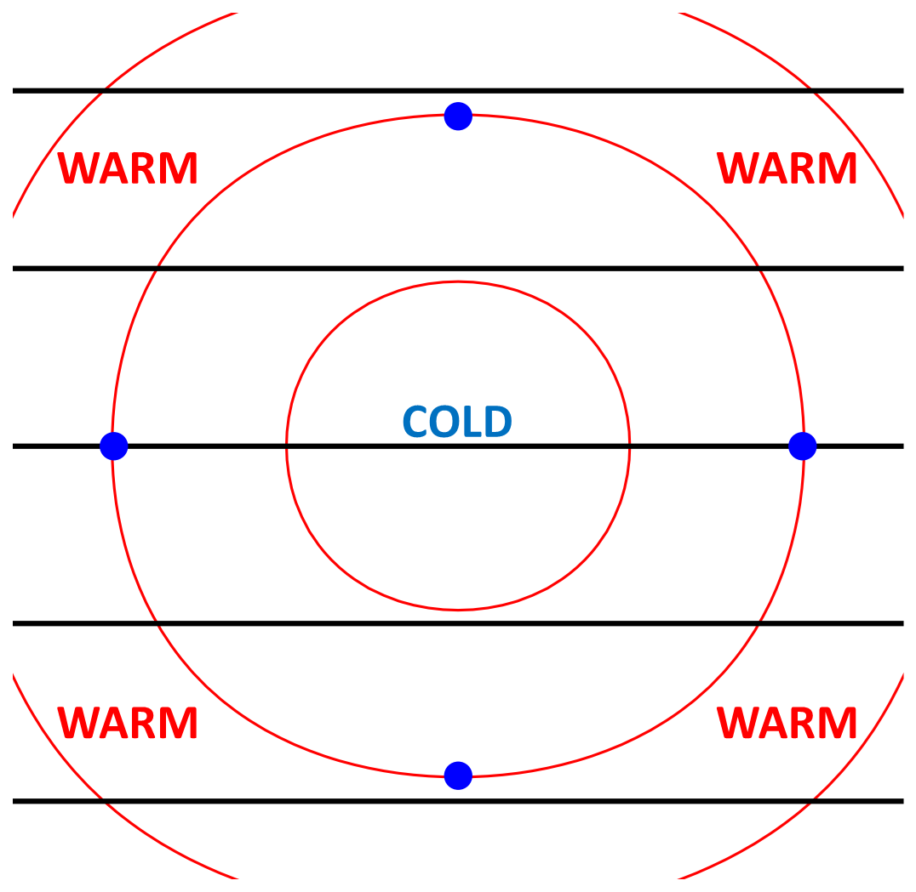

1. Can vertical motion result isotherm curvature alone? Explain using your answers to Question 13. (5 pts)